Lab 4

1. Use a similar baseline model as in Lab 3 with architecture 64, 64, 64, 10. Turn it into Keras functional API model:
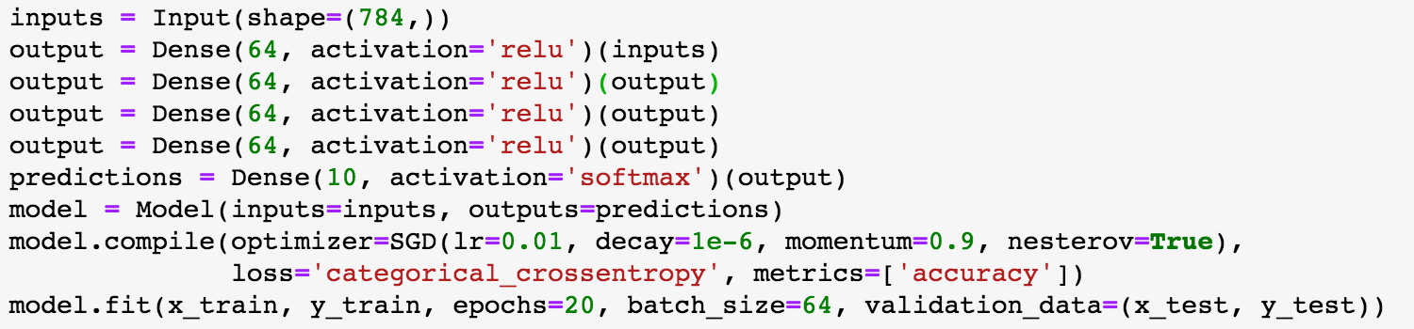
This baseline model gets an accuracy of .9760 after 20 epochs training with batch size 64, which takes 104s.

2.

